Best Practices

Dividing students into different subgroups which are known as learning circles. Students create their own learning circle- what’s app group. They are given different assignments to work as a group. Students discuss the assignments in what’s app groups. Work as a group and post their assignments in google classroom. Assignment details and marks are posted on the Jam board.
For eg:
- Students are asked to select a particular TV Channel and watch the news and they would fill in the survey questionnaire posted on google classroom.
- Critical Analysis of Video Clipping on Caste System and Problems of Dalits, Problems of Women, etc., posted on Google Classroom Assignment page and writing their learning points.
- Reading, materials posted in the google classroom, and answering the questions on the assignment page.

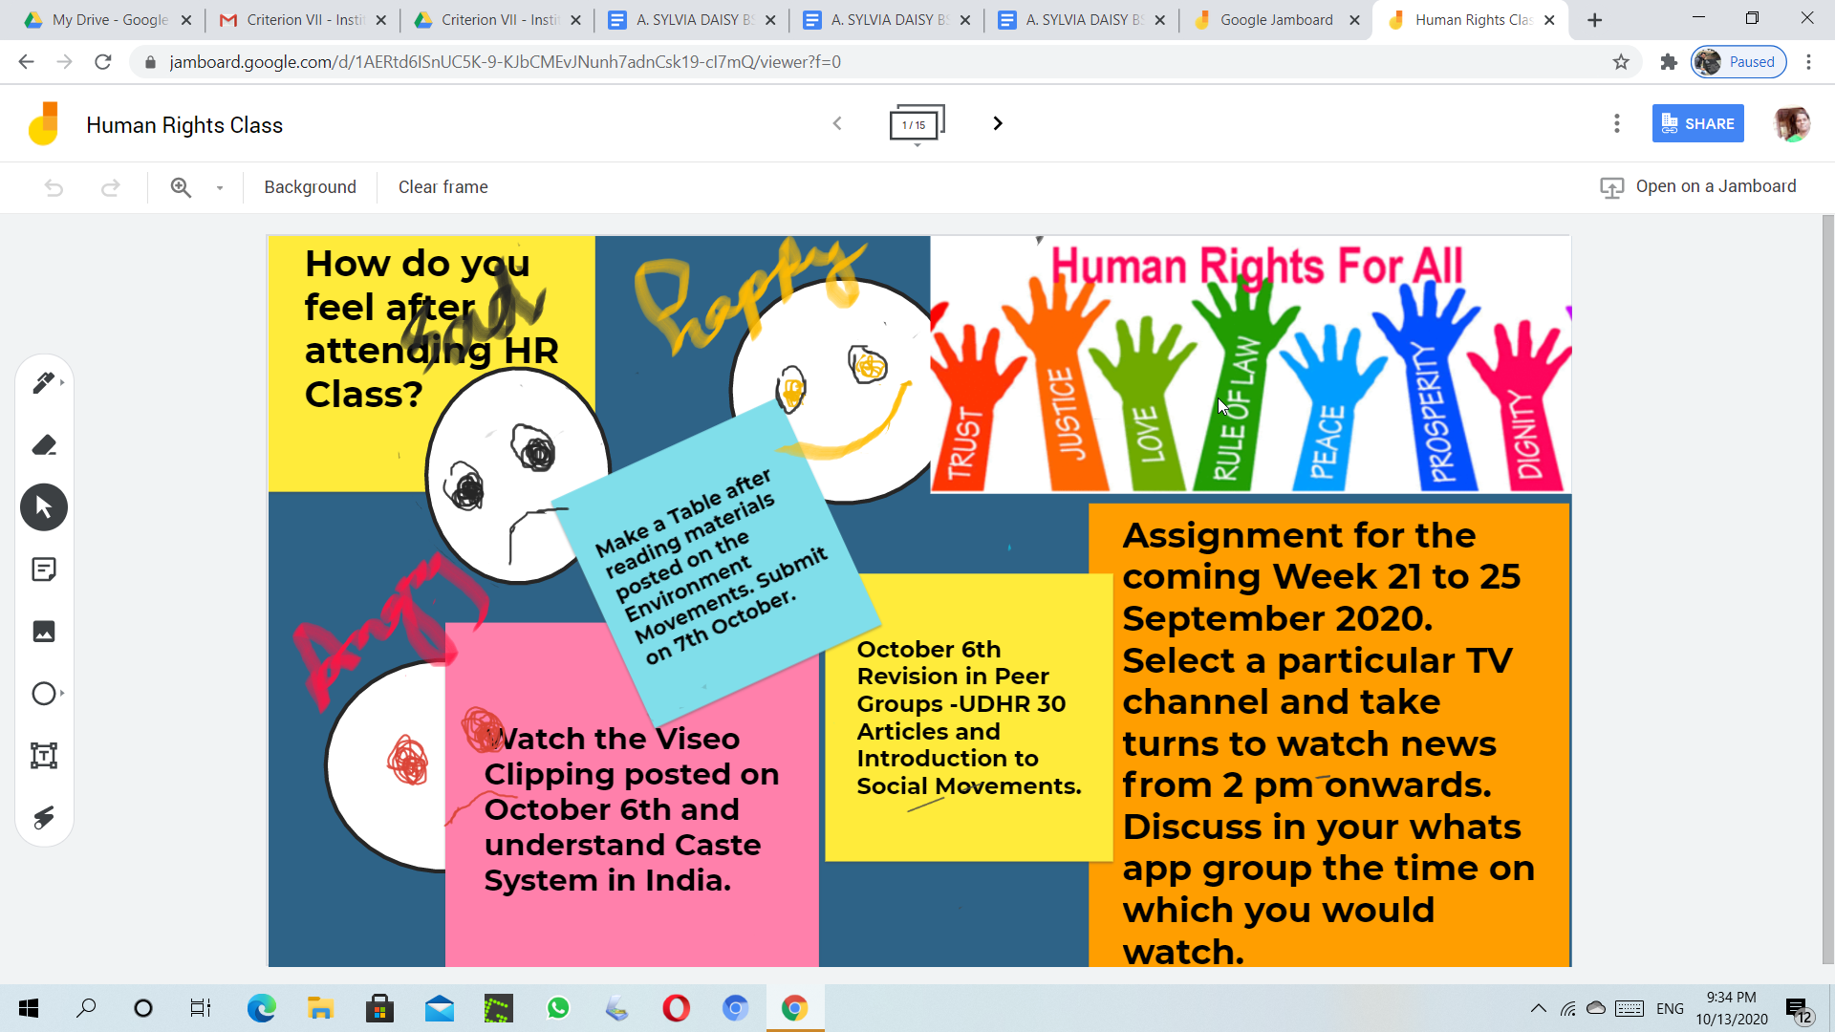

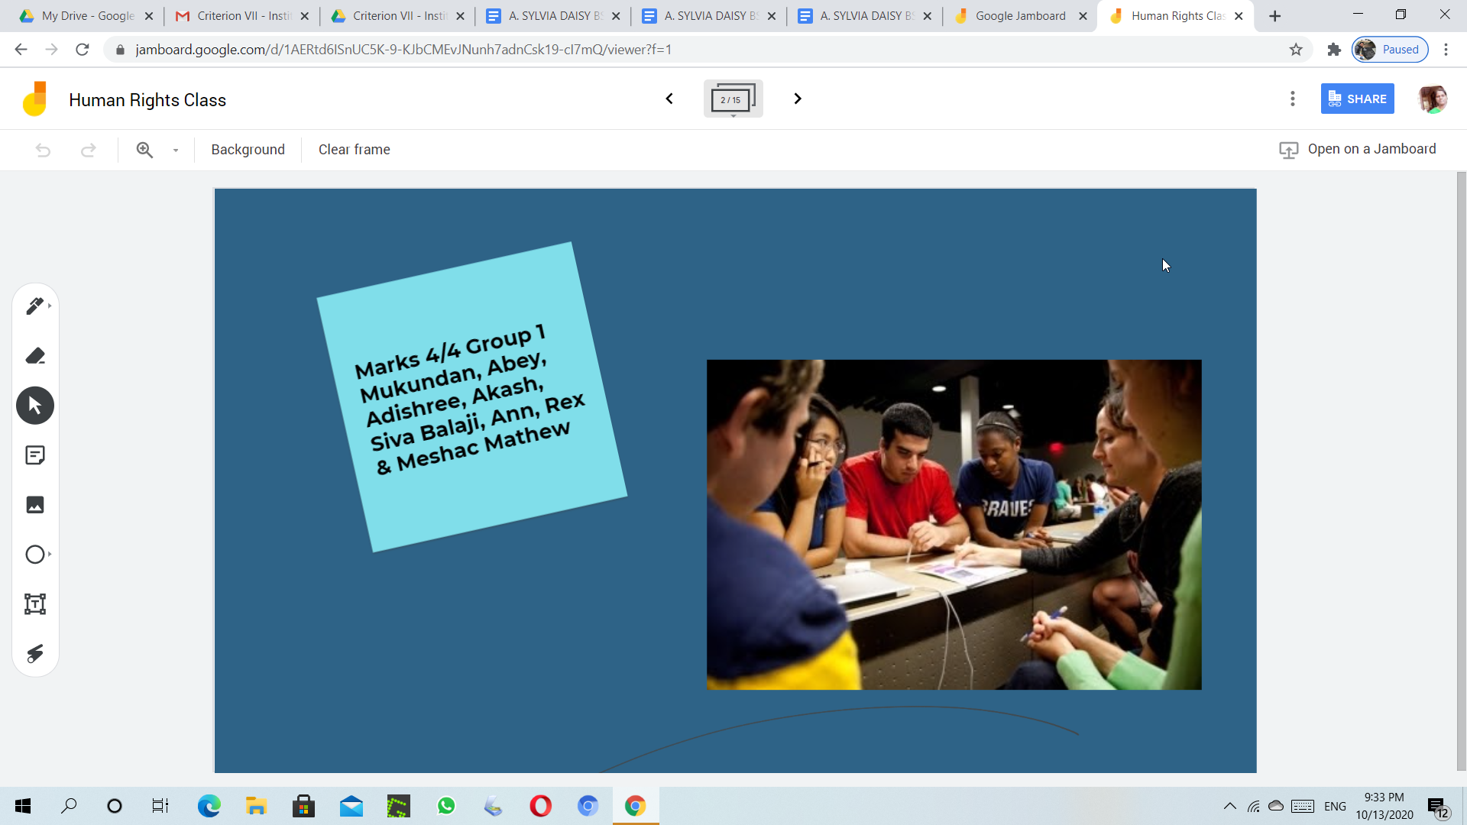
2. Students are asked to leave class if they are sad or not able to pay attention after notifying the teacher on their Jam Board. It helps in safeguarding student’s privacy.

3. The google classroom recordings are posted so that it is easier for slow learners, late joiners, and absentees to learn.

3. Students are encouraged to use social media platforms such as Facebook and Twitter in a responsible manner.

4. Students are taught on the concepts of research and guided to undertake an online survey as a small group.

5. What’s app is used effectively to disseminate information on human rights violations and social action. Interested students are encouraged to participate.

6 Case study presentations.

Institutional Values Promoted
Unity among students is promoted as they work in a small group.
The value service to humanity is promoted by knowledge dissemination on problems of the weaker and vulnerable sections of society.

