Innovative methods of teaching / Best Practices -
Department of Languages –Hindi -SFS
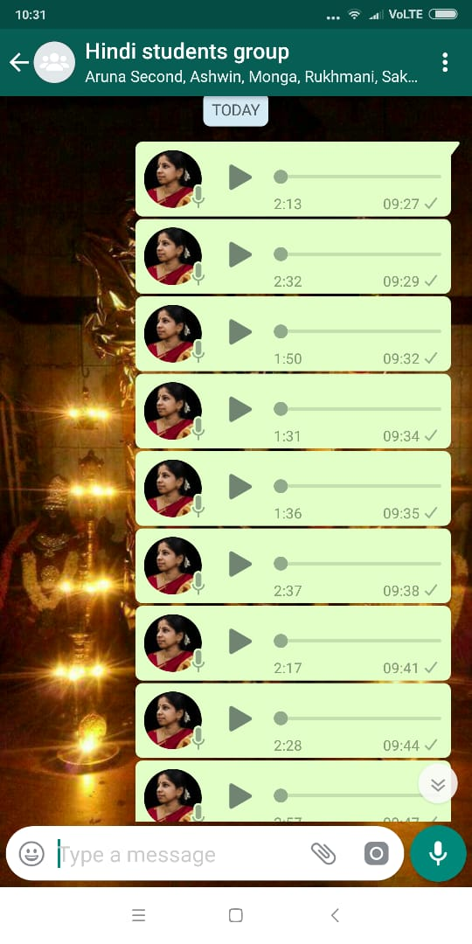
- Audio explanations or lectures (through WhatsApp) for the students who missed the classes.
- This also enables to clear their doubts regarding the lessons or topics.
- Students are advised and encouraged to converse only in Hindi during Hindi Classes
- Students are also encouraged to enact the plays in the form of a skit as a part of their Continuous Assessment
- Students are encouraged to participate in all the Hindi inter-collegiate academic and cultural competitions/Programs.
- Cordial Faculty-Student relationship

Best Practices -
Skit performances by Students-

