Lion Dr P. Sivaraj Memorial Award

Madras Christian College has been awarded ‘Lion Dr P. Sivaraj Memorial Award’ by the Lions Club of Central Madras, on 25th May 2019 for propagating, encouraging and organizing Voluntary Blood Donation Camps for many years.

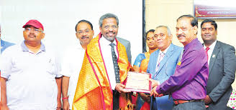

Higher Education Excellence Award - 2019

Our College has received the ‘Higher Education Excellence Award - 2019’ Arts & Science Colleges, Chennai, from the Staffordshire University, UK and Education Matters, on 23rd July 2019.

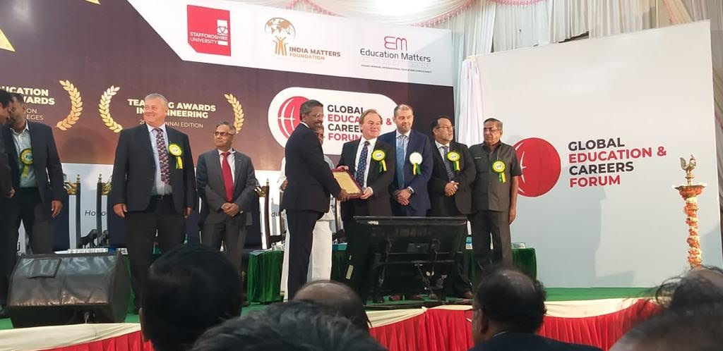

ThinkEdu Award for ‘Excellence in Education’

Our College has received ‘ThinkEdu Award for Excellence in Education’, from the Hon’ble Chief Minister of Tamil Nadu, on 9th January 2020.

